We are absolutely thrilled you are interested to join us at Rohlik Group. By now we have spoken to you about your experience and personality in great detail. Next step is to find out how you tackle a task in reality.

**Category Manager**

**Situation**

You are working as a category manager for Rohlik.cz The following items are available on the market.

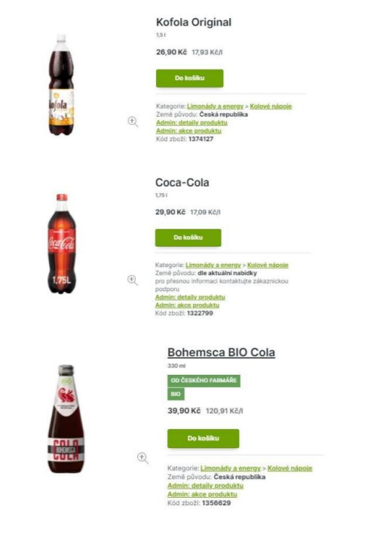

**Task**

• Question 1) - Which article do you choose and why?

• Question 2) - How would you choose a price strategy ?

• Question 3 ) - Which customer group would be targeted by each product?

• Question 4) - How would you set a marketing campaign for each product?

• Question 5 ) - How will each product influence supply and logistic chain?

**Format**

Result of the case study should be captured in a format of your choice that is easily shareable with us during the next meeting. We don’t need you to write essays, clear and consistent content is much more important to us. Please send us the presentation materials of your Case study 1 day prior to the meeting so we can review and get ready for the talk.